**Mr. Visca’s: Calculus (sec 7.3 part 1)**

**Chpt 7 – Day 5 – part 1: Slices for Volume**

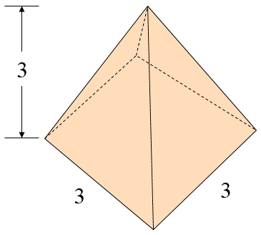

Find the volume of the pyramid:

Vpyramid = _______________

Consider a horizontal slice through the pyramid.

The volume of the slice is __________________

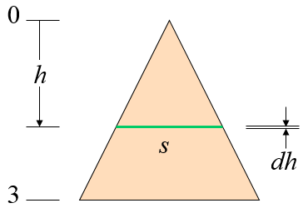

If we put zero at the top of the pyramid and

make down the positive direction, then ________________

Vslice = _______________

Therefore the volume of the pyramid, which is the sum of all the slices, is...

V =

**Method of Slicing (section 7-3, p400):**

1. Sketch the ____________ and a typical ______________ section.
2. Find a ________________ for *V*(*x*).

(Note that we used *V*(*x*) instead of *A*(*x*).)

1. Find the _______________ of integration.
2. _________________ *V*(*x*) to find volume.

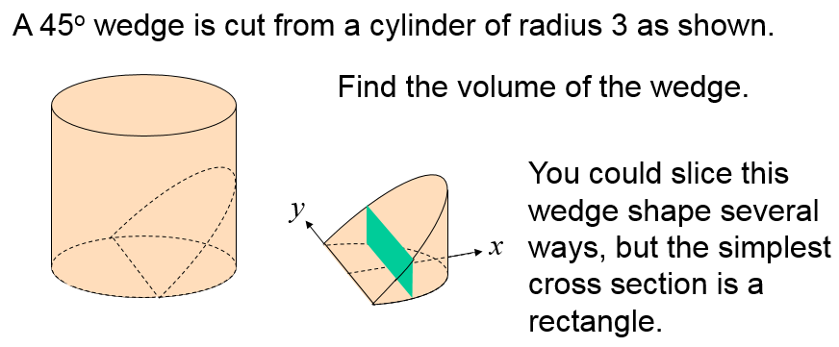

If we let *h* equal the height of the slice then the volume of the slice is: Vslice(x) =

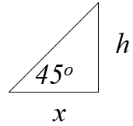

Since the wedge is cut at a 45o angle, therefore, it forms an isosceles, 45-45-90 triangle,

Then: ___________, and ____________________ so,

$${V(x)}_{slice}=2y∙h∙dx$$

 ______________________

* _________________________
* _________________________

**Cavalieri’s Theorem:**

Two solids with equal ____________________ and ____________________ parallel cross sections have the same ____________________.

